**CLOUD FRONT- TASK**

1. **Configure VPC peering in cross regions.**

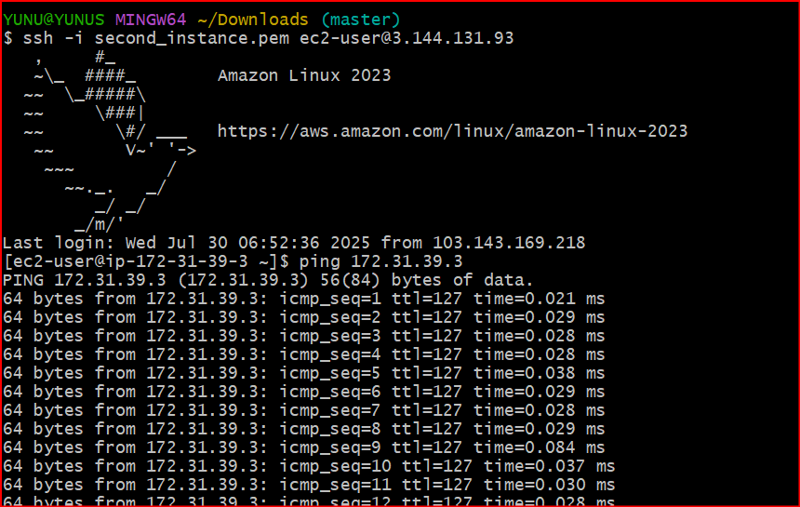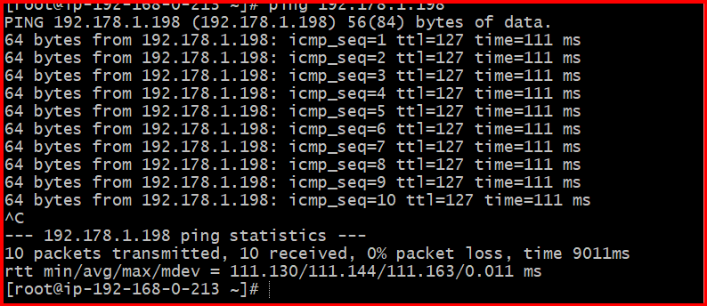

**2) Purchase one domain from godaddy.**

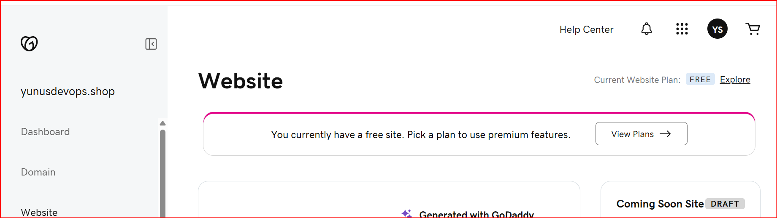

**3) Deploy static webiste in s3.**

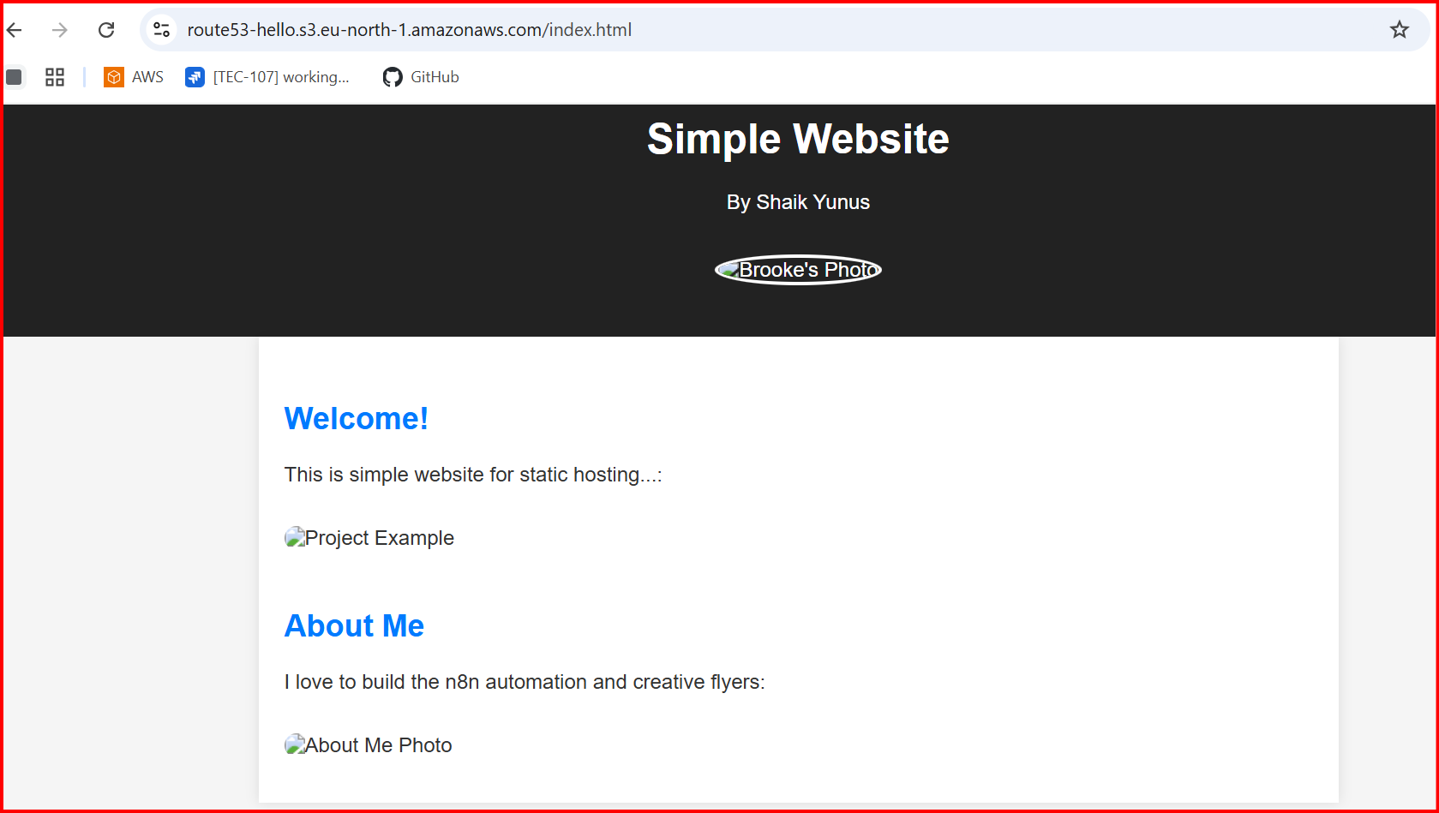

**4) Create CDN and attach one SSL certificate.**

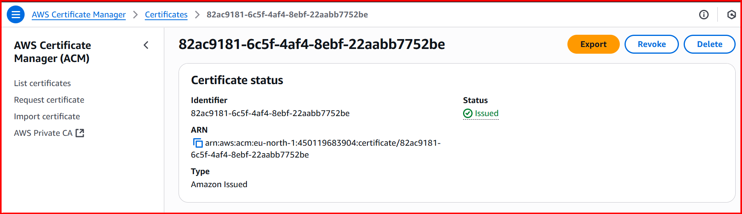

**5) Create Route53 hosted zone and MAP the domain with CDN.**

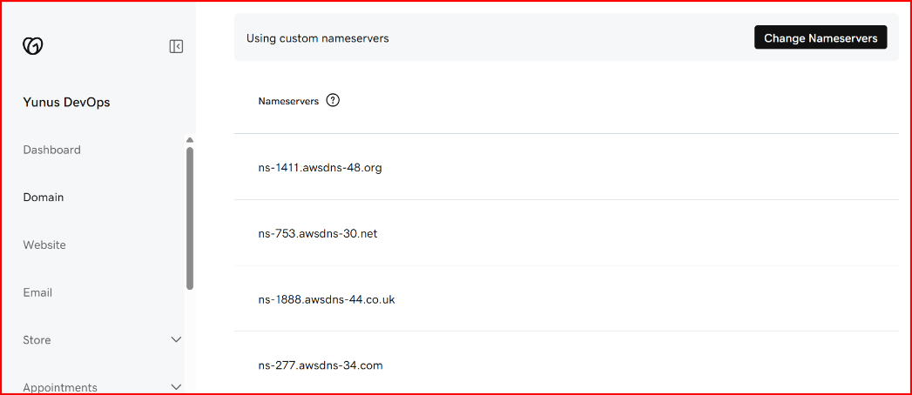

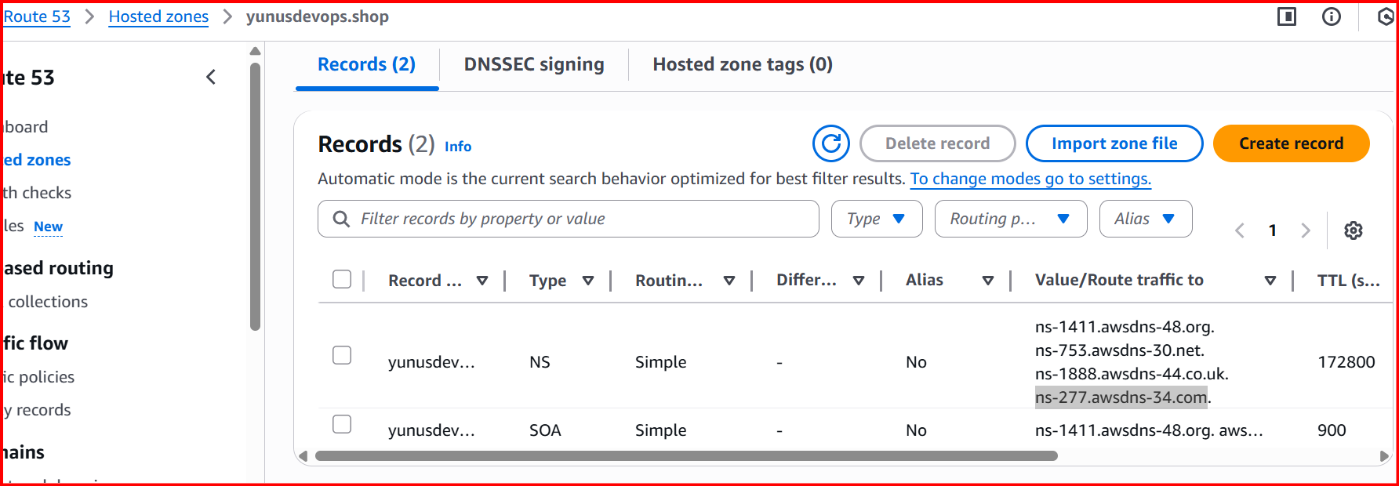

**6) Update the index.html in s3 bucket and the updated file should be accessible by using domain name.**

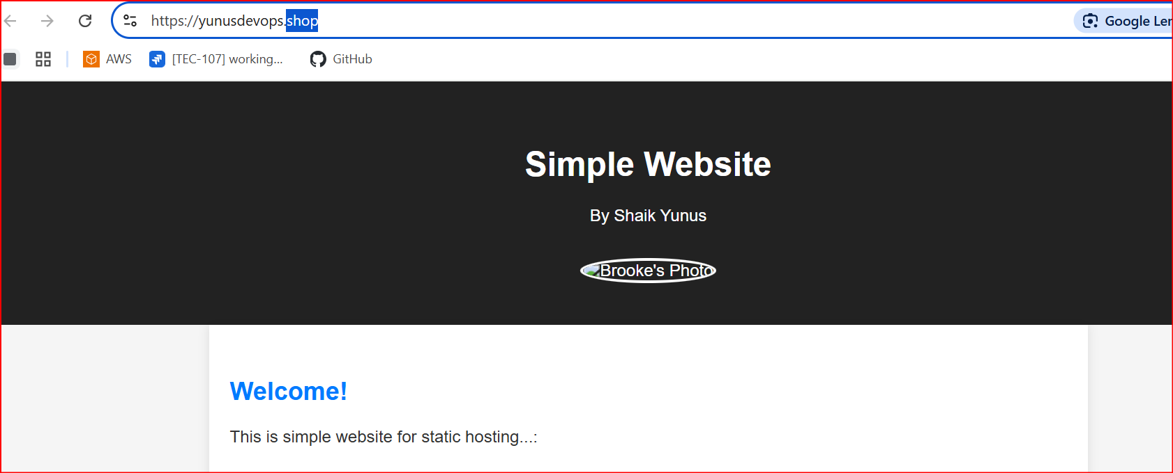

**7) Share the Domain name in slack to test the connetivity.**

[**https://yunusdevops.shop/**](https://yunusdevops.shop/)